**8 - Introduction to Importing Data in ServiceNow**

Importing data into ServiceNow via integrations involves three key data entities:

**Source -** The entity where the data to be imported originates.

**Staging -** A temporary table created by ServiceNow during the import process to store data from the source before it is transformed and moved to the target.

**Target -** The ServiceNow table where the data is ultimately imported.

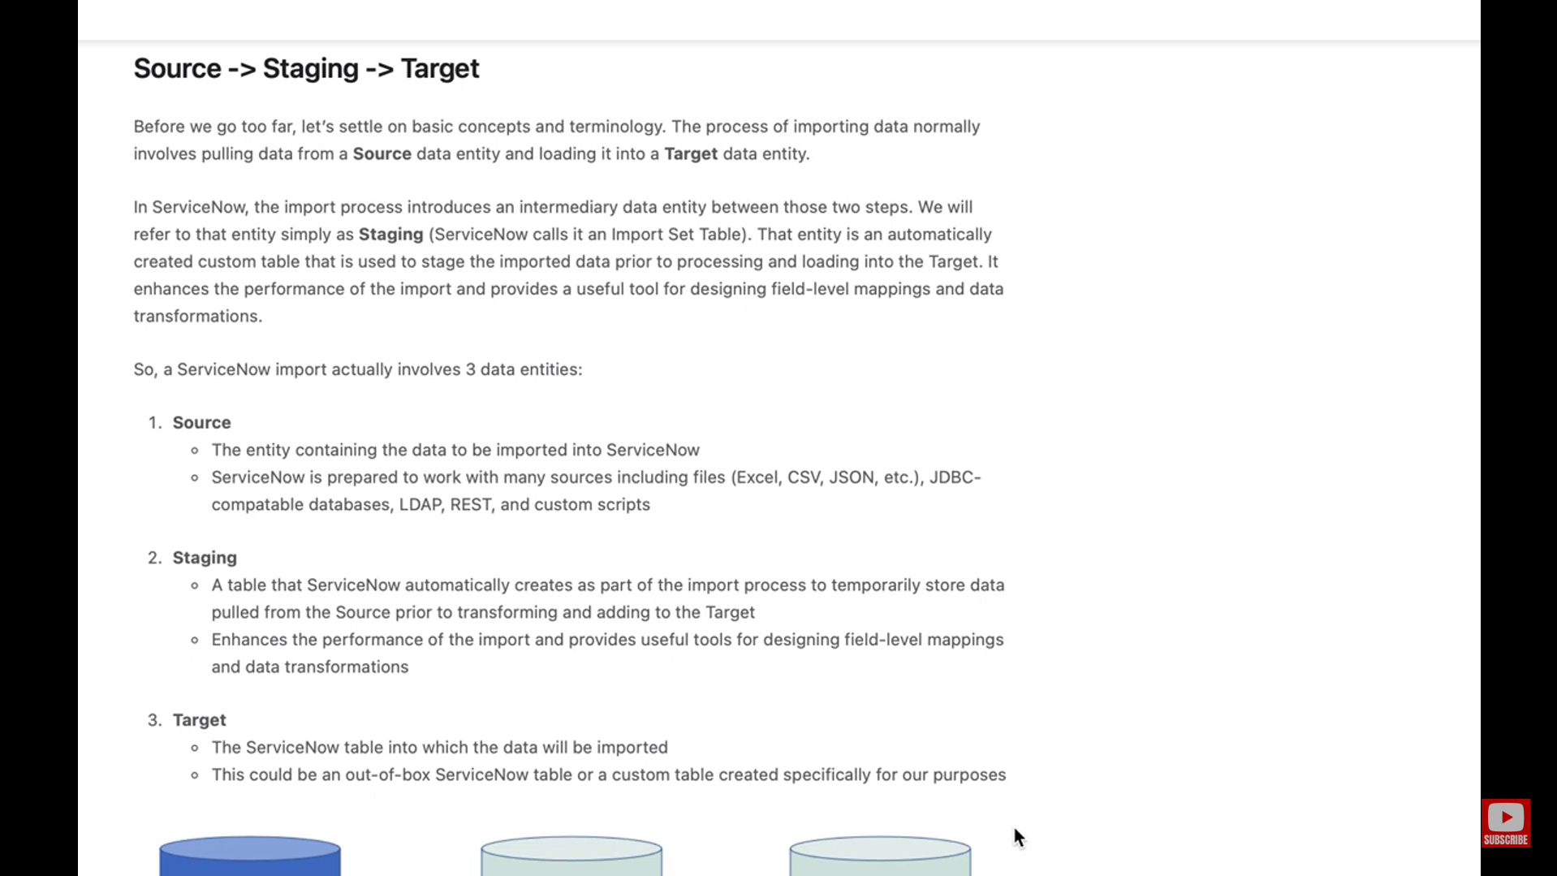

ANANYA CHOUDHARY